***AIDS MICROPROCESSOR LAB S21 BATCH (2023-24)***

***Experiment 8 Title: Assembly language programming to display content of flag register***

***Name of student: Meet Raut Class Roll Number: 2201084***

***Date of Performance: 01/04/2024***

***Batch: S2-1 Timing: 3:00-5:00 Date of Submission: 01/04/2024***

***Assembly language code***

*DATA_SEG SEGMENT*

*CHAR DB 17H*

*MSG1 DB '-- -- -- -- OF DF IF TF SF ZF -- AX -- PF -- CF',0AH,'$'*

*FLAG DW ?*

*DATA_SEG ENDS*

*CODE_SEG SEGMENT*

*ASSUME CS:CODE_SEG, DS:DATA_SEG*

*START:*

*MOV AX,DATA_SEG*

*MOV DS,AX #INITIALIZE DATA SEGMENT*

*MOV AH,09H #09 SERVICE*

*LEA DX,MSG1 #ADDRESS OF MSG1 IS STORED IN DX*

*INT 21H #DISPLAYING THE LINE*

*MOV AL,0FFH #DISPLAY FLAG REGISTER*

*ADD AL,02H #MAKING CARRY FLAG 1*

*CLD #CLEARING DIRECTION FLAG*

*STI #SETTING INTERRUPT FLAG*

*PUSHF #PUSHING THE CONTENT OF FLAG REGISTER ONTO STACK*

*POP BX #POPING CONTENTS INTO BX REGISTER*

*MOV FLAG,BX #SAVED TO MEMORY*

*MOV CX,16 #INITALIZE COUNTER*

*MOV BX,8000H #STORING 1000 0000 0000 0000*

*FLAG_LOOP:*

*MOV AX,FLAG #LOAD FROM MEMORY*

*AND AX,BX #GETTING REQUIRED BIT*

*JZ DISP_0 #IF BIT IS ZERO JUMP TO DISPLAY*

*MOV DL,31H #STORING 1 IN DL*

*MOV AH,02H #02H SERVICE*

*INT 21H #DISPLAY THE LINE*

*MOV DL,' '*

*INT 21H*

*INT 21H #DISPLAYING THE SPACES*

*JMP NEXT #JUMP TO NEXT*

*DISP_0:*

*MOV DL,30H #STORING 0 IN DL*

*MOV AH,02H #02H SERVICE*

*INT 21H #DISPALY*

*MOV DL,' '*

*INT 21H*

*INT 21H #DISPLAYING SPACES*

*NEXT:*

*ROR BX,1 #ROTATE RIGHT BX REGISTER BY 1*

*LOOP FLAG_LOOP #LOOP FOR ALL BITS*

*MOV AH,4CH*

*INT 21H #EXIT TO DOS*

*CODE_SEG ENDS*

*END START*

*Result:*

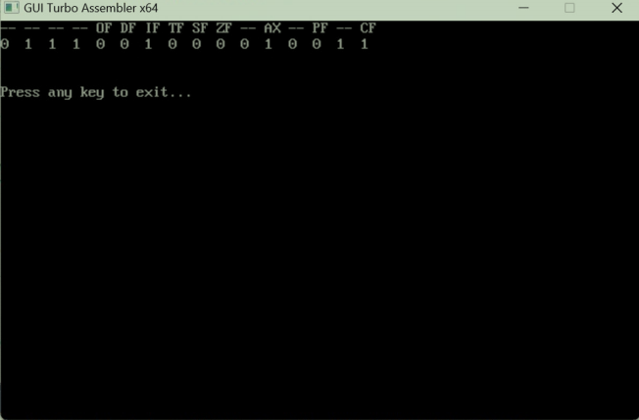

*CONCLUSION: LO 2, LO 3 mapped.*

***---------------------------------*****************************-----------------------------------***